|  |
| --- |
|  |
| 新概念 3 册 |
| Lesson26 |

Lesson 26 Wanted, a large biscuit tin

**influence ['ɪnflʊəns]**

**n. 影响**

**the influence of … on / upon …**

the influence of parents on / upon their children

the effect of … on / upon …

the effect of fertilizers on / upon the crops the impact of … on / upon …

the impact of the oil spill on / upon marine life

pride [praɪd]

**v. 骄傲**

be proud of … take pride in … pride oneself on … **taste [teɪst]**

n. 鉴赏力，品味

Phoebe: Oh that’s good, I guess she’ll have a choice between my guy and your weirdo. Chandler: Why would our guy be a weirdo?

Phoebe: Because that’s just your taste.

a man / woman of taste have … taste in …

She has good taste in music.

He has terrible taste in clothing. tasteless

exert [ɪɡ'zɜ:t]

**v. 施加**

exert … on …

My wife exerts a lot of pressure on me to make more money.

…, for advertising exerts a subtle influence on us.

Antique shops exert a peculiar fascination on a great many people.

impose sth. on sb.

Some parents impose their own moral values on their children.

inflict sth. on sb.

Please don’t inflict your love on me.

devise [dɪ'vaɪz]

**v. 设计，想出**

The cartoon character Mickey Mouse was devised by Walt Disney in 1928.

conceive come up with

Very few people come to it.

A good name hasn’t been found for it.

People don’t like climbing the stairs to get there.

She has decided to phone the ticket office.

M: What had they decided to call the stadium? W: No one has come up with a good name.

Q: What does the woman say about the stadium? Answer: (B) A good name hasn’t been found for it. **wanted: 诚聘, 求购**

help wanted section

He wants help improving his vocabulary.

He plans to read the entire newspaper.

He rarely has time to read the newspaper on Sunday.

He's interested in finding a job.

W: Since when do you read the Sunday Times? M: Since I discovered its big help-wanted section. Q: What can be assumed about the man?

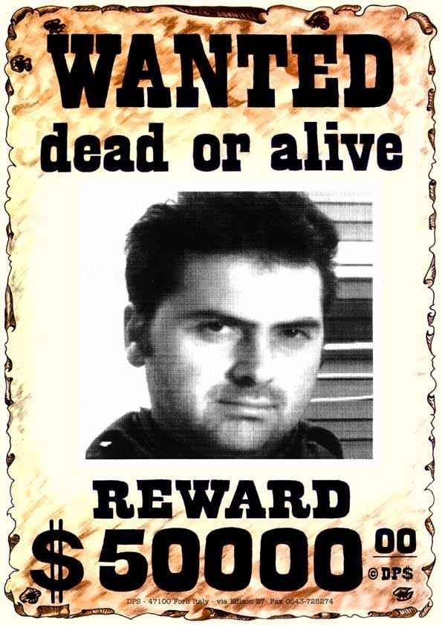Answer: (D) He's interested in finding a job.

The fugitive is wanted by the police.

**avoid v. 躲避，避免**avoid sb. like the plague avoid doing

造句：没有人可以避免受到社会的影响。No one can avoid being influenced by society. 造句：没有人可以避免受到金钱的引诱。No one can avoid being tempted by money. 造句：没有人可以避免犯错误。

No one can avoid making mistakes. Everyone is influenced by advertisements.

➔ No one can avoid being influenced by advertisements. Everyone admits that …

➔ No one can deny that … Everyone is attracted by …

➔ No one can resist …

Much as we may pride ourselves on our good taste, we are no longer free to choose the things we want, *for advertising exerts a subtle influence on us*.

pride oneself on ... take pride in ...

**be proud of ...**

Although we may much pride ourselves on our good taste, ... Much *as* we may pride ourselves on our good taste, …

Although I much admire Newton as a scientist, I don’t like him as a man. Much *as* I admire Newton as a scientist, I don’t like him as a man.

Although we may be proud of our good taste, ... Proud as we may be of our good taste, ...

Although she is beautiful, I still don’t like her. Beautiful *as* she is, I still don’t like her.

Although he tries, he never seems able to do the work beautifully. Try *as* he does, he never seems to do the work beautifully.

Although he is a child, he can make a living. Child *as* he is, he can make a living.

be free to do …

You are free to choose the things you want. freely

You can choose the things you want freely.

be at liberty to do

You are at liberty to choose the things you want.

In their efforts to persuade us to buy this or that product, advertisers have made a close study of human nature and have classified all our little weaknesses.

in sth. / doing

In trying to persuade us to buy …

In seeking independence, they do not sacrifice their human dignity.

persuade sb. to do / into doing talk sb. into doing

We talked Father into buying the car.

get sb. to do

The rough road across the plain soon became so bad that we tried to get Bruce to drive back to the village we had come from.

persuade sb. not to do / out of doing talk sb. out of doing

get sb. not to do dissuade sb. from doing

造句：我劝他不要自杀 (commit suicide)

I persuaded him not to commit / out of committing suicide.

I talked him out of committing suicide. I got him not to commit suicide.

I dissuaded him from committing suicide. this or that product

one product or another some product or other study …

make a study of ...

Recently the New York Animal Medical Center made a study of 132 cats over a period of five months.

study …

make a study of ... make a *close* study of … discover

make an *interesting* discovery of …

Some time ago, an interesting discovery was made by archaeologists on the Aegean island of Kea. describe

make a *vivid* description of … investigate

make a *thorough* investigation of …

summarize

make a *comprehensive* summary of…

analyze

make a *detailed* analysis of …

weakness 1. 懦弱, 软弱 [U]

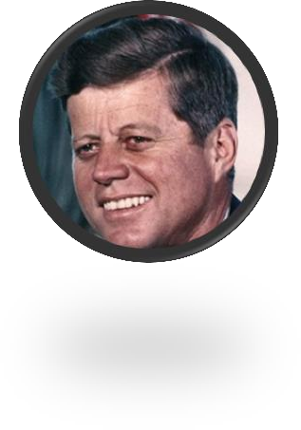So let us begin anew —remembering on both sides that civility is not a sign of weakness, and sincerity is always subject to proof. Let us never negotiate out of fear, but let us never fear to negotiate.

— John F. Kennedy

weakness 1. 懦弱, 软弱 [U]

**2. 弱点, 缺点 [C]**

**反义: strength 优点, 长处 [C]**

**strengths and weaknesses**

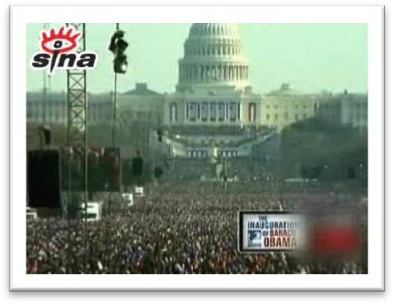For we know that our patchwork heritage is a strength, not a weakness. We are a nation of Christians and Muslims, Jews and Hindus, and nonbelievers.

Advertisers discovered years ago that all of us love to get something for nothing. for nothing / for free / free of charge adv. 免费……

Guests can park for nothing / for free / free of charge. no charge for … ……免费

There is no charge for parking. be on the house 店主请客How much do I owe you?

Well, that'll be eighteen dollars and seventy cents. No charge for the cleanup. It's on the house.

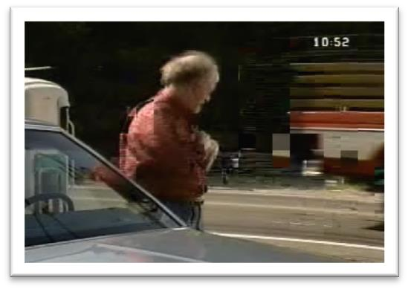

An advertisement which begins with the magic word FREE can rarely go wrong.

begin with …

Let’s go into the kitchen, and maybe you can help me set the table. *Sounds good to me. What are we having?* I prepared lamb chops, mashed potatoes, and a tossed green salad to begin with. *Grandpa, you are a terrific guy!*

begin with … end with …

The rally ended with the singing of national anthem.

go wrong 出错，出问题，不顺利

Something’s gone wrong with my computer.

We have all experienced days when everything goes wrong. round / around the world

throughout the world all over the world

the world over

Michael Jackson was popular ~.

enable sb. to do ...

**make it possible for sb. to do ...**

Radio and television have made it possible for advertisers to capture the attention of millions of people in this way.

Radio and television have enabled advertisers to capture the attention of millions of people in this way.

**capture / attract / draw / catch / arrest / command / get *(one’s) attention / the attention of …*** This attracted the attention of Richard Humphries who was then the most eminent boxer in England.

True eccentrics never deliberately set out to draw attention to themselves.

bake baker

**baker’s / bakery**

roast

roast turkey Peking roast duck **grill / broil**

grilled / broiled chicken barbecue (BBQ)

She paid me $30 for my bike. She bought my bike for $30.

Advertisers discovered years ago that all of us love to get something for nothing.

The manufacturers had to pay more money than they had anticipated, for they bought the biscuit from the student for $24,000.

the response to … is / was tremendous / lukewarm

造句：学校提供了一笔 1000 美元的奖金给第一个能解决这个问题的学生。大家对这次比赛的反应很热烈/很平淡。

In 1908 Lord Northcliffe offered a prize of ₤1,000 to the first man who would fly across the English Channel.

The university offered a prize of $1,000 to the first student who would find a solution to the problem. The response to the competition was tremendous / lukewarm.

before (very / too) long

**before much longer shortly afterwards**

Shortly afterwards, the police stopped the car and both men were arrested. before (very / too) long

before much longer shortly afterwards a little later

A little later, a man came along with a biscuit which occupied the whole boot of his car. before (very / too) long

before much longer shortly afterwards a little later

after a *little / short* time / while

After a little time, she chose one of the most expensive dresses in the shop and handed it to an assistant who wrapped it up for her as quickly as possible.

all sorts / kinds / types of sth.

He added that a student had dressed up as a policeman and was playing all sorts of silly jokes on people.

造句：她每天必须要处理各种各样的投诉。

She has to deal with all kinds of complaints every day.

weigh …

The boy weighs 50 kilos.

be … (in weight)

The boy is 50 kilos (in weight).

be / stand … high / tall

She stood three feet high and her hands rested on her hips. He stands / is 1.8m tall.

rise to a height of …

Above the surface of the water, the towers rise to a height of nearly 700 feet.

be … deep / in depth

The hole is 2 feet deep / in depth. extend to a depth of …

The platforms extend to a depth of over 100 feet under the sea. be … long / in length

The bed is 2 meters long / in length. be … wide / across / in width

The river is 20 meters wide / across / in width. along with …

Mr. Taylor, along with two assistants, *is* trying to stop the thieves.

together with ... coupled with ... accompanied by ...

**followed by ...**

**besides ... as well as ...**

**no less than ... including ...** The largest was 713 pounds (in weight). The largest weighed 713 pounds.

But just before the competition closed, a lorry arrived at the factory *with a truly colossal biscuit which weighed 2400 pounds*.

造句：箱子太沉了，用了一辆卡车才把它运到目的地。

The box was so heavy that a lorry had to be used to carry it to the destination.

造句：两年多来这条街上新开了很多商店。

In the past two years many shops have been set up in the street. A new government was organized after the war.

战后成立了新政府。